**242 BROADHOLLOW ROAD**

**Farmingdale, NY**

**» +/- 18,450 Sq. Ft. on 1.1 Acre Parcel**

**» 66 Tons HVAC Servicing Upscale Showroom & Offices**

**» On-site Parking for +/- 48 Cars**

**» Gas Heat » 400 Amps » Sprinkler System » Connected to Sewers**

**» Raised Loading Dock Platform**

**» LED Lighting Throughout**

**» Rubber Membrane Roof with 10 Years Left on Guarantee**

**» 104’ Frontage on Route 110**

**» Traffic Volume +/- 70,200 Cars Daily**

**+/- 18,450 Square Foot Commercial Building**

**For Sale or Lease**

**EXCLUSIVE**

**242 BROADHOLLOW ROAD |FARMINGDALE**

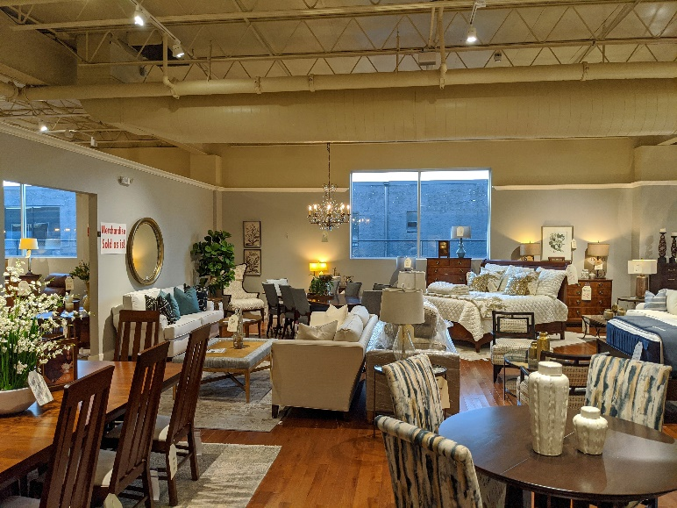

No warranty or representation, express or implied, is made as to the accuracy of the information contained herein, and same is submitted subject to errors, omissions, change of price, rental or other conditions, withdrawal without notice, and to any special listing conditions, imposed by our principals.

No warranty or representation, express or implied, is made as to the accuracy of the information contained herein, and same is submitted subject to errors, omissions, change of price, rental or other conditions, withdrawal without notice, and to any special listing conditions, imposed by our principals.

No warranty or representation, express or implied, is made as to the accuracy of the information contained herein, and same is submitted subject to errors, omissions, change of price, rental or other conditions, withdrawal without notice, and to any special listing conditions, imposed by our principals.

**AS BUILT FLOOR PLAN**

